1 You can your Pi in **Headless mode** (using TightVNC on your PC/Laptop to remotely control the Pi). To do this the Pi must first be connected to your network. You can simulate a network by connecting the Pi directly to the Ethernet Port of your PC/Laptop. (You can even power the Pi from a USB port)

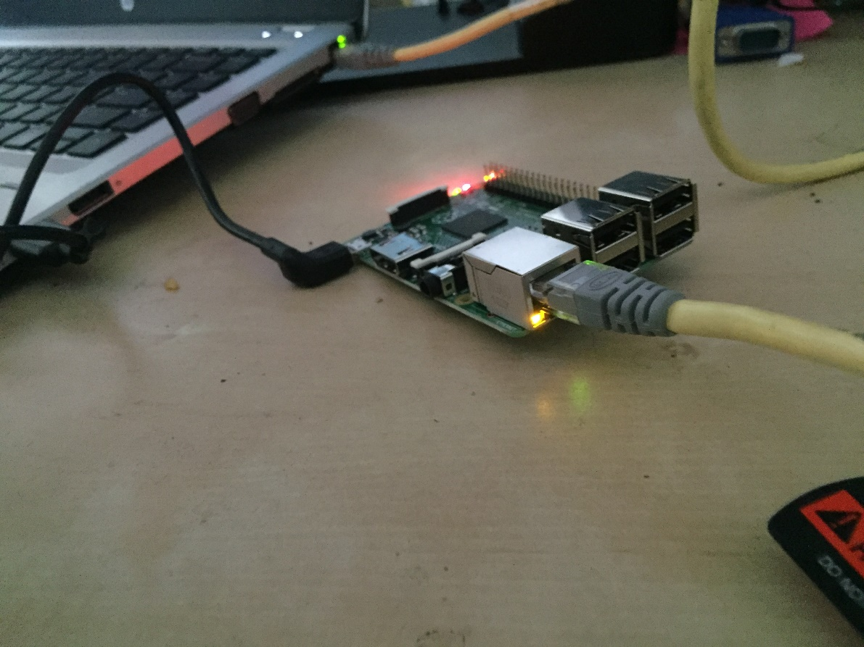

Windows Users

2 The first step is to enable Internet Sharing. Go to the Control Panel and Open the Network and Sharing Centre

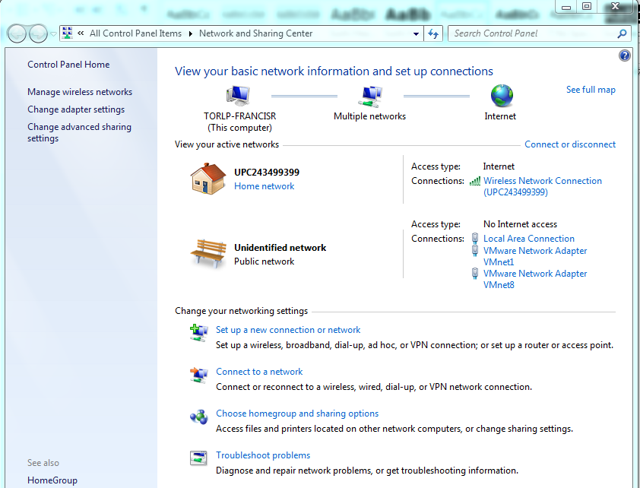

3 Now click on the **Wireless** connection you are using to connect to the Internet, click on **Properties** and then click the **Sharing** tab.

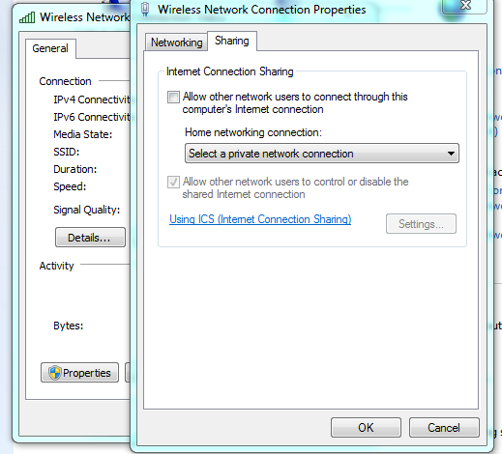

4 Now allow sharing the Wifi connection with the **Local Area Connection.**

*In windows 10 the home networking drop down may not be present.*

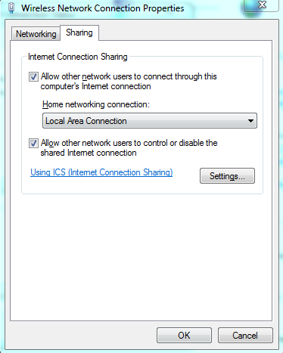

By default windows will manage a private network to the Local Area Network and will automatically provide a **private** IP Address to the Pi (or any device) connected to it.

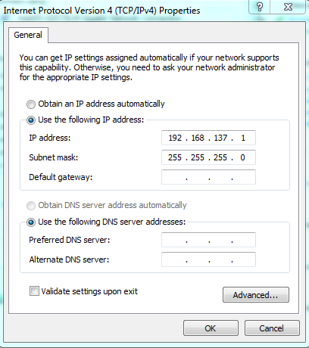

The Pi Address will be dynamically allocated from the same IP Range.

***For Apple Mac OSX Users you can achieve the same by enabling Internet Sharing in the Sharing option of System Preferences. The Default IP Range for Mac OSX will be 192.168.3.0/24.***

5 The address the Pi will get may vary each time the Pi is connected. One method of finding the Pi is to ping each available IP address. A command line batch file ‘findmypi.bat’ is included to help automate this.

***For Mac OSX users you should find that the arp table is updated automatically.***

Once you have run this once, you can now check the arp table to see what computers are known: run this command in a Command Prompt/Terminal Window

arp -a

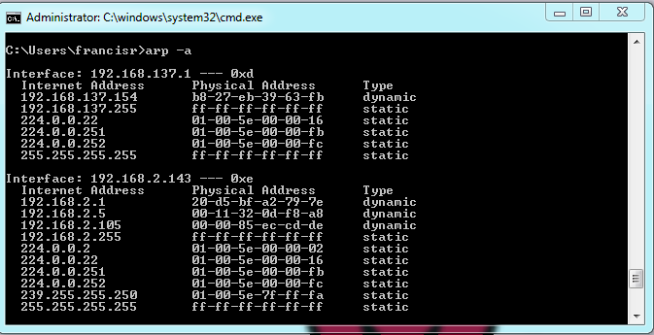

Look at the list to find the MAC Address of your Pi. You can then remotely access your Pi!.

*Once you have located your Pi, you can then use Putty to connect to it. To access the Desktop of the Pi you will need to install TightVNC on both your PC and your Pi. Refer to other Sushi cards in this collection to find out how to do this.*

***For Mac OSX users you can open a Terminal Window.***

6 Finally, when using this method you may need to set the DNS address manually on the network preferences on the Pi if you want to surf the internet or download additional content to the Pi.

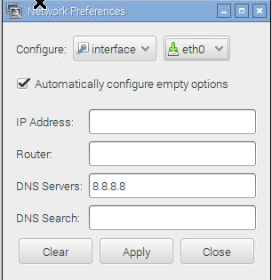

If you have not yet got access to the GUI interface, then you can set this from the command line by editing a file /etc/resolv.conf:

$ sudo nano /etc/resolv.conf

and adding the line:

nameserver 8.8.8.8

No reboot is required

*8.8.8.8 is google’s DNS server you may use a different value if needed.*

*The next time you connect your Pi to your PC/Laptop it may get a different address. You will need to check the address of your Pi each time it boots.*

Mac OSX Users